 | 2 day |  |  |  |  |  |  |  |  |  |  | 1 day
 | 200+ | 100- | Results | Declarn | Inns | Mts | Dec% | 200% | 100% | R% |  | 200+ | 100- | Inns | 200% | 100%
85/86 | 39 | 7 | 21 | 63 | 156 | 40 | 40.38 | 25.00 | 4.49 | 52.50 |  | 16 | 4 | 60 | 26.67 | 6.67
86/87 | 36 | 6 | 19 | 86 | 170 | 45 | 50.59 | 21.18 | 3.53 | 42.22 |  | 22 | 4 | 80 | 27.50 | 5.00
87/88 | 54 | 7 | 29 | 66 | 176 | 45 | 37.50 | 30.68 | 3.98 | 64.44 |  | 25 | 5 | 90 | 27.78 | 5.56
88/89 | 68 | 2 | 26 | 79 | 176 | 45 | 44.89 | 38.64 | 1.14 | 57.78 |  | 19 | 0 | 60 | 31.67 | 0.00
89/90 | 63 | 5 | 23 | 57 | 153 | 40 | 37.25 | 41.18 | 3.27 | 57.50 |  | 23 | 2 | 70 | 32.86 | 2.86
90/91 | 71 | 2 | 25 | 74 | 179 | 45 | 41.34 | 39.66 | 1.12 | 55.56 |  | 27 | 4 | 80 | 33.75 | 5.00
91/92 | 62 | 7 | 27 | 72 | 159 | 40 | 45.28 | 38.99 | 4.40 | 67.50 |  | 29 | 7 | 80 | 36.25 | 8.75
92/93 | 44 | 10 | 30 | 66 | 175 | 45 | 37.71 | 25.14 | 5.71 | 66.67 |  | 24 | 9 | 78 | 30.77 | 11.54
93/94 | 34 | 4 | 30 | 65 | 157 | 40 | 41.40 | 21.66 | 2.55 | 75.00 |  | 28 | 6 | 80 | 35.00 | 7.50
94/95 | 44 | 12 | 32 | 72 | 178 | 45 | 40.45 | 24.72 | 6.74 | 71.11 |  | 24 | 4 | 90 | 26.67 | 4.44
95/96 | 42 | 8 | 23 | 64 | 159 | 40 | 40.25 | 26.42 | 5.03 | 57.50 |  | 24 | 3 | 78 | 30.77 | 3.85
96/97 | 30 | 13 | 24 | 53 | 136 | 35 | 38.97 | 22.06 | 9.56 | 68.57 |  | 11 | 8 | 66 | 16.67 | 12.12
97/98 | 41 | 16 | 30 | 53 | 174 | 44 | 30.46 | 23.56 | 9.20 | 68.18 |  | 26 | 7 | 78 | 33.33 | 8.97
98/99 | 20 | 11 | 22 | 39 | 129 | 36 | 30.23 | 15.50 | 8.53 | 61.11 |  | 15 | 4 | 64 | 23.44 | 6.25
99/00 | 25 | 15 | 13 | 19 | 94 | 35 | 20.21 | 26.60 | 15.96 | 37.14 |  | 24 | 5 | 63 | 38.10 | 7.94
00/01 | 39 | 6 | 17 | 33 | 118 | 32 | 27.97 | 33.05 | 5.08 | 53.13 |  | 13 | 5 | 56 | 23.21 | 8.93
01/02 | 23 | 13 | 27 | 37 | 131 | 36 | 28.24 | 17.56 | 9.92 | 75.00 |  | 13 | 3 | 40 | 32.50 | 7.50
02/03 | 25 | 14 | 23 | 51 | 115 | 32 | 44.35 | 21.74 | 12.17 | 71.88 |  | 25 | 4 | 64 | 39.06 | 6.25
03/04 | 33 | 5 | 20 | 58 | 134 | 36 | 43.28 | 24.63 | 3.73 | 55.56 |  | 18 | 1 | 76 | 23.68 | 1.32
04/05 | 45 | 5 | 13 | 39 | 97 | 30 | 40.21 | 46.39 | 5.15 | 43.33 |  | 21 | 6 | 64 | 32.81 | 9.38
05/06 | 32 | 10 | 18 | 28 | 99 | 30 | 28.28 | 32.32 | 10.10 | 60.00 |  | 19 | 3 | 71 | 26.76 | 4.23
06/07 | 28 | 10 | 21 | 38 | 139 | 40 | 27.34 | 20.14 | 7.19 | 52.50 |  | 25 | 6 | 67 | 37.31 | 8.96
07/08 | 38 | 6 | 17 | 44 | 122 | 40 | 36.07 | 31.15 | 4.92 | 42.50 |  | 26 | 4 | 68 | 38.24 | 5.88
 | 200+ | 100- | Results | Declarn | Inns | Mts | Dec% | 200% | 100% | R% |  | 200+ | 100- | Inns | 200% | 100%

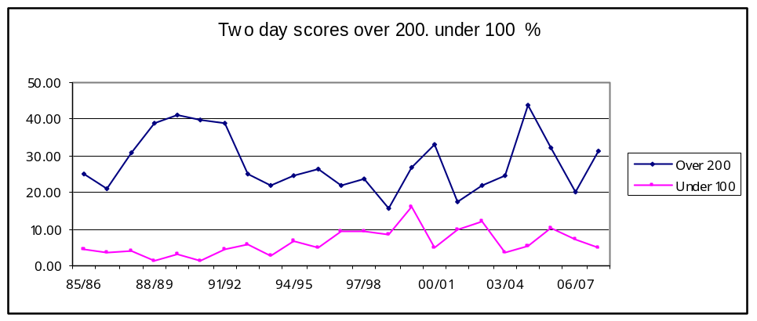

One Day Club Cricket Competition
0.00
10.00
20.00
30.00
40.00
50.00
85/86
88/89
91/92
94/95
97/98
00/01
03/04
06/07
Over 200 as %
Under 100 as a %

Scores over 200 2 day 1 day compared
0.00
10.00
20.00
30.00
40.00
50.00
85/86
88/89
91/92
94/95
97/98
00/01
03/04
06/07
2 day
1 day

Scores under 100 2 day 1 day compared
0.00
3.00
6.00
9.00
12.00
15.00
18.00
85/86
88/89
91/92
94/95
97/98
00/01
03/04
06/07
2 day
1 day

